For most of the scenarios, you will need only a Clinician (i.e., holder of both ORES and PROVIDER keys). For scenario #3, you will also need a Student (i.e., holds no OR-namespaced keys and is set up to require cosignature for the Anticoagulation Note Titles). For scenario #4, you will also need a Primary Care Provider to place a consult request.

NOTE: Exercise all scenarios in your TEST account before installing OR*3.0*339 to replicate and identify the problems. Exercise all test cases AFTER installing OR*3*339 to confirm resolution. Moreover, we recommend that you perform the structured tests in your TEST account, and only watch for any recurrence of each of the problems after installing patch OR*3*339 in your PRODUCTION account. Although Scenarios 1, 2, & 10 may be executed without storing any information in the database, and could be run in either account, the rest of the scenarios require storing data in the database, and pose an unnecessary risk in PRODUCTION.

Scenario #1:

Remedy Ticket #418906, PSPO #1813

Problem with auto-calculation of daily dosage occurs when user is in the midst of editing daily dosage, and elects to change pill strength. To replicate the problem, follow these steps:

1. Log-in to CPRS, and select a patient who is enrolled in Anticoagulation.
2. Launch the Anticoagulator from the CPRS tools menu, and click on the Enter Information tab.
3. Click the button to Change daily dosing. You should see something like the following:

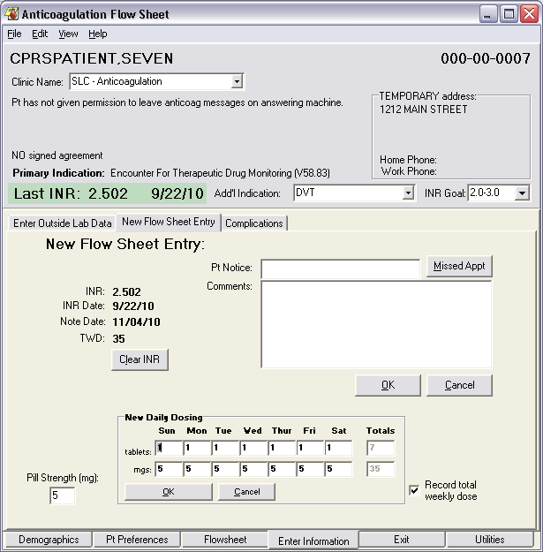

1. Modify the dosage for Sunday to ten tablets:

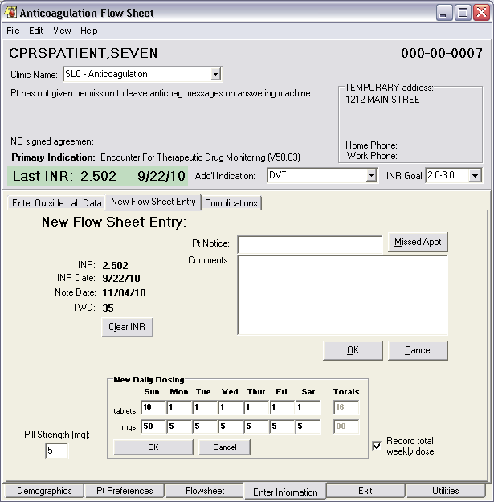

Note the daily and weekly dosages in both tabs and mgs.

1. Without clicking OK or Cancel, change the Pill Strength to 10 mg:

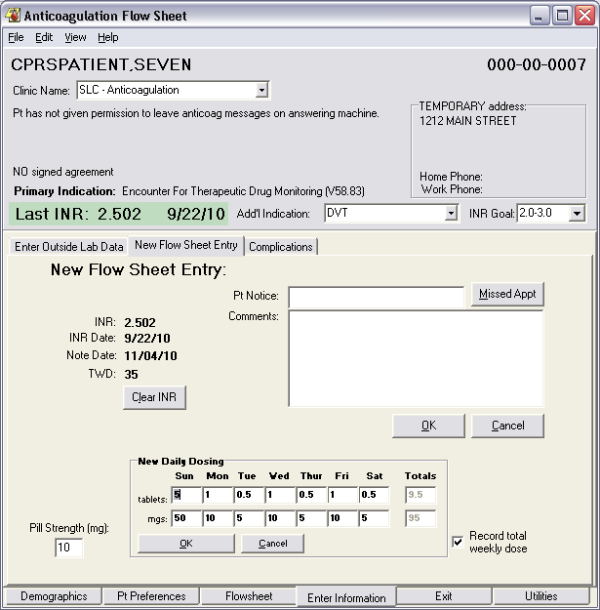

When you tab back to the dosing box, note the changes to tabs and mgs.

Note that this anomaly will only be apparent when you modify the pill strength while the daily dosing is being actively changed. Changing the pill strength before clicking the button to Change daily dosing will result in the correct recalculation of daily dosage.

Scenario #2:

Remedy Ticket #424310, PSPO #1823

Problem: replacing the number of tablets in daily dosing may result in a zero being appended unintentionally. To replicate the problem, follow these steps:

1. Log-in to CPRS, and select a patient who is enrolled in Anticoagulation.
2. Launch the Anticoagulator from the CPRS tools menu, and click on the Enter Information tab.
3. Click the button to Change daily dosing. You should see something like the following:

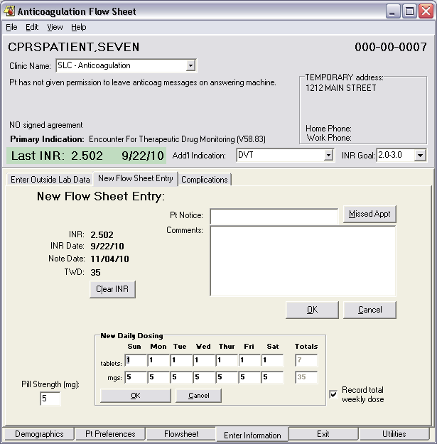

Note that the tablets for Sunday are automatically selected.

1. Without typing anything else, press the Delete key. Note that the current number of tablets is replaced by a zero (0), and the cursor is placed before the zero (i.e., at the home position in the edit box):

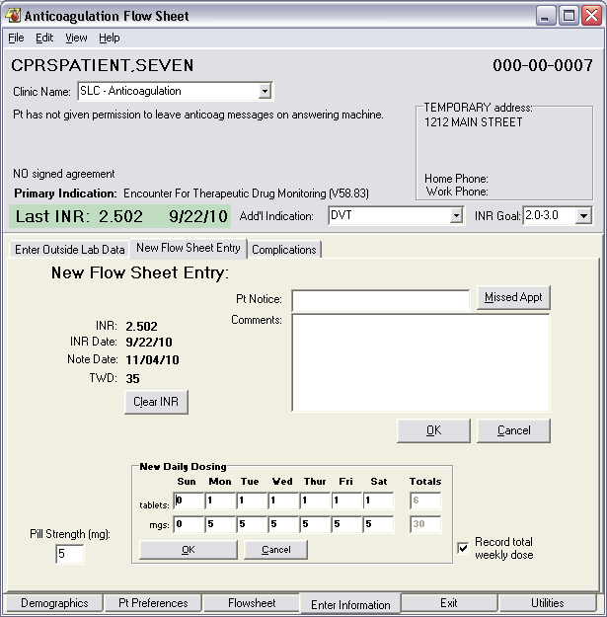

1. Now, type any digit, and observe that the zero is appended.

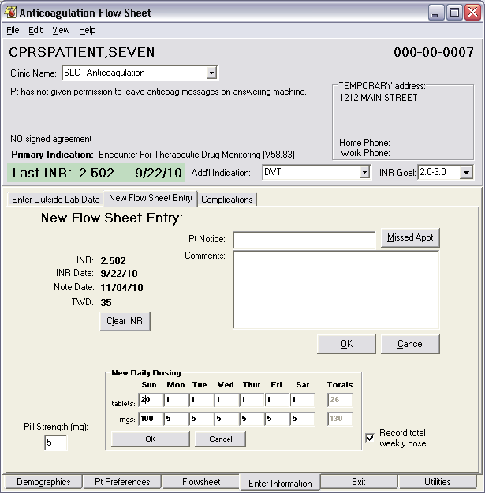

Note: *if the user isn’t paying attention*, this could result in the intended dosage being changed by an order of magnitude.

Scenario #3:

Remedy Tickets #392179, & #406932

Problem: when a non-Provider (e.g., Student, Intern, Technician, etc.) uses the Anticoagulator to document their encounter, the resulting Visit in PCE is left with an invalid Primary Provider (i.e., the Student) and workload isn’t correctly sent to Austin. To replicate the problem, follow these steps:

1. Log-in to CPRS as a Student, Intern, or Technician (i.e., a user who has no OR-namespaced security keys and requires a cosigner for Anticoagulation Note Titles), and select a patient who is enrolled in Anticoagulation.
2. Launch the Anticoagulator from the CPRS tools menu, and click on the Enter Information tab.
3. Enter the patient notice and comments and click OK:

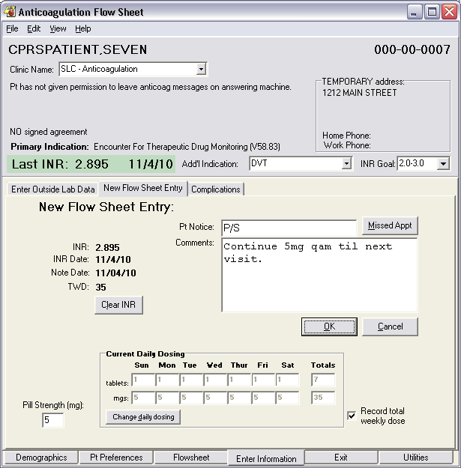

1. Proceed to the Exit tab, and enter a future Return date. Be sure that the checkbox to order an INR is checked and the radio button indicating a simple phone visit is selected. Enter and sign an Interim Note. Choose a valid cosigner. Click the complete visit button.

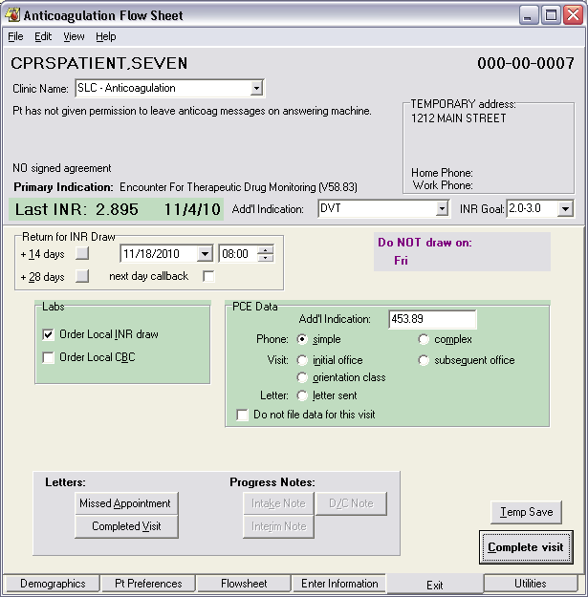

1. Check Yes or No for each of the Service Connection/Exposure questions and choose a valid Provider for the order(s), and click OK. The Anticoagulator will close.
2. Log-in to VistA, and invoke the PCE Coordinator’s menu [PX PCE COORDINATOR MENU].
3. Choose the PCE Encounter Data Entry – Supervisor option, and select the patient for whom the Student just completed the encounter using Anticoagulator:

SUP PCE Encounter Data Entry - Supervisor

PCE PCE Encounter Data Entry

DEL PCE Encounter Data Entry and Delete

NOD PCE Encounter Data Entry without Delete

TBL PCE Table Maintenance ...

INFO PCE Information Only ...

HOME Directions to Patient's Home Add/Edit

MDR CIDC Missing Data Report

PARM PCE HS/RPT Parameter Menu ...

DIE PCE Device Interface Error Report

VIEW PCE Encounter Viewer

Select PCE Coordinator Menu Option: **SUP** PCE Encounter Data Entry - Supervisor

Select Patient or Clinic name: **CPRSPATIENT,SEVEN** *SENSITIVE* *SENSITIVE* NO EMPLOYEE THIS IS A TEST

***WARNING***

***RESTRICTED RECORD***

* * * * * * * * * * * * * * * * * * * * * * * * * * * * * * * * * * * * *

* This record is protected by the Privacy Act of 1974 and the Health *

* Insurance Portability and Accountability Act of 1996. If you elect *

* to proceed, you will be required to prove you have a need to know. *

* Accessing this patient is tracked, and your station Security Officer *

* will contact you for your justification. *

* * * * * * * * * * * * * * * * * * * * * * * * * * * * * * * * * * * * *

Do you want to continue processing this patient record? No// **Y** (Yes)

WARNING : You may have selected a test patient.

...OK? Yes// **<Enter>** (Yes)

**PCE Appointment List** Nov 04, 2010@14:09:50 Page: 1 of 1

CPRSPATIENT,SEVEN 000-00-0007 Clinic: All

Date range: 9/5/2010 to 11/5/2010 Total Appointment Profile

* - New GAF Score Required

Clinic Appt Date/Time Status

No appointments meet criteria.

+ Next Screen - Prev Screen ?? More Actions

UE Update Encounter CD Change Date Range VC View by Clinic

LI List by Encounter GF GAF Score DD Display Detail

AD Add Standalone Enc. IN Check Out Interview EP Expand Appointment

AL Appointment Lists PC PC Assign or Unassign QU Quit

TI Display Team Info

SP Select New Patient

Select Action: Quit// **LI** List by Encounter

1. Select List by Encounter. The screen will be rebuilt to present you with the list of recent visits. Select the number that corresponds to the visit that your Student just created, and press the Enter key to view the details of the visit from PCE:

**PCE Encounter List** Nov 04, 2010@14:09:52 Page: 1 of 1

CPRSPATIENT,SEVEN 000-00-0007 Clinic: All

Date range: 9/5/2010 to 11/5/2010

* - New GAF Score Required

Encounter Clinic Appointment Status

1 11/4/2010 13:42 SLC - ANTICOAG TELEPHONE CHECKED OUT

2 9/22/2010 15:35 SLC - ANTICOAG TELEPHONE CHECKED OUT

3 9/17/2010 15:28 SLC - ANTICOAG TELEPHONE CHECKED OUT

+ Next Screen - Prev Screen ?? More Actions

UE Update Encounter SP Select New Patient VC View by Clinic

LI List by Appointment CD Change Date Range DD Display Detail

AD Add Standalone Enc. CC Change Clinic GF GAF Score

HI Make Historical Enc. IN Check Out Interview

PN Enter/Edit Document PC PC Assign or Unassign QU Quit

TI Display Team Info

PB Patient Problem List Encounter Edit

Select Action: Quit// **1** 1

**PCE Update Encounter** Nov 04, 2010@14:09:57 Page: 1 of 1

CPRSPATIENT,SEVEN 000-00-0007 Clinic: SLC - ANTICOAG TELEPHONE

Encounter Date 11/4/2010 13:42 Clinic Stop: 317 ANTI-COAGULATION CLIN

1 Encounter Date and Time: NOV 04, 2010@13:42:17

2 Provider: DENT,STUART ARTHUR PRIMARY ## No Person Class ##

3 ICD9 Code or Diagnosis: V58.83 ENCTR THERAP DRUG MONITOR

Provider Narrative: Encounter For Therapeutic Drug Monitoring (V58.83)

Primary/Secondary Diagnosis for the Encounter: PRIMARY

4 ICD9 Code or Diagnosis: 453.89 AC EMBOLISM VEINS NEC

Provider Narrative: DVT

5 CPT Code: 98967 HC PRO PHONE CALL 11-20 MIN

Primary Diagnosis: V58.83 ENCTR THERAP DRUG MONITOR

+ Next Screen - Prev Screen ?? More Actions

ED Edit an Item TR Treatment DD Display Detail

DE Delete an Item IM Immunization DB Display Brief

EN Encounter PE Patient Ed IN Check Out Interview

PR Provider ST Skin Test QU Quit

DX Diagnosis (ICD 9) XA Exam

CP CPT (Procedure) HF Health Factors

Select Action: Quit//

Notice that the student is recorded as the Primary Provider for the Encounter, and that they are correctly identified as having no Person Class (which will prevent the visit from being properly credited by Austin).

Scenario #4:

Remedy Ticket #404437

Problem: Consult requests with the status of “Scheduled” are not completed when an Initial Note is filed, unlike requests for which the status is either “Pending” or “Active.” To replicate the problem you’ll need two clinicians: one who is a primary care provider and another who is an update user in the consult service for Anticoagulation identified in your clinic parameters for Anticoagulator. Follow these steps:

1. Log-in to CPRS as the Primary Care Provider, and select a patient who is ***NOT*** yet enrolled in Anticoagulation.
2. From the Orders Tab, request a consult from the Service you set up for Anticoagulation:

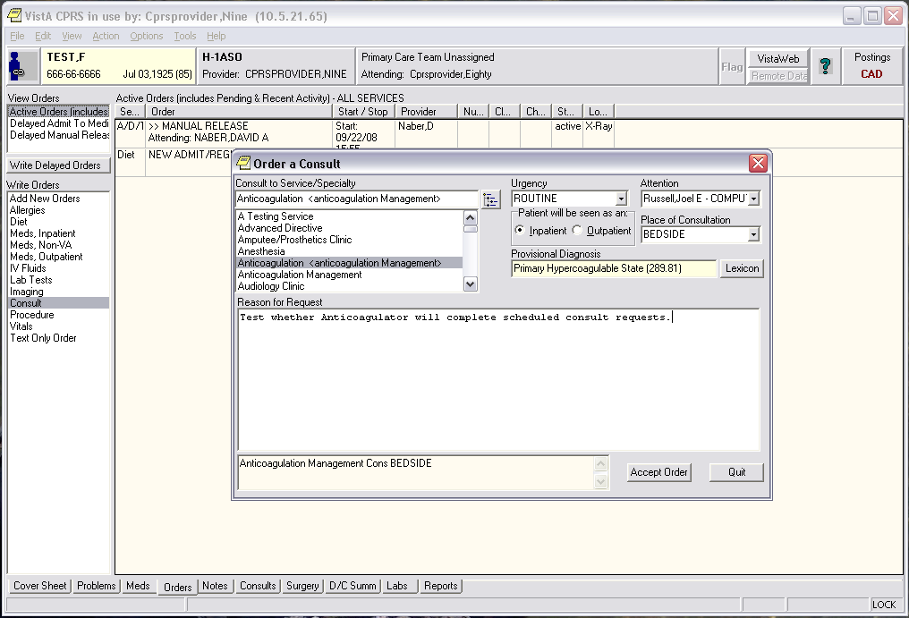

1. Make the request for the Attention of your Anticoagulation clinician.
2. Accept the order and exit from CPRS, signing the request on your way out.
3. Log-in to CPRS as your Anticoagulation clinician.
4. You should have a notification of the new consult request in the Notifications area of your patient selection dialog.
5. Choose the request and navigate the menu to Action | Consult Tracking | Schedule:

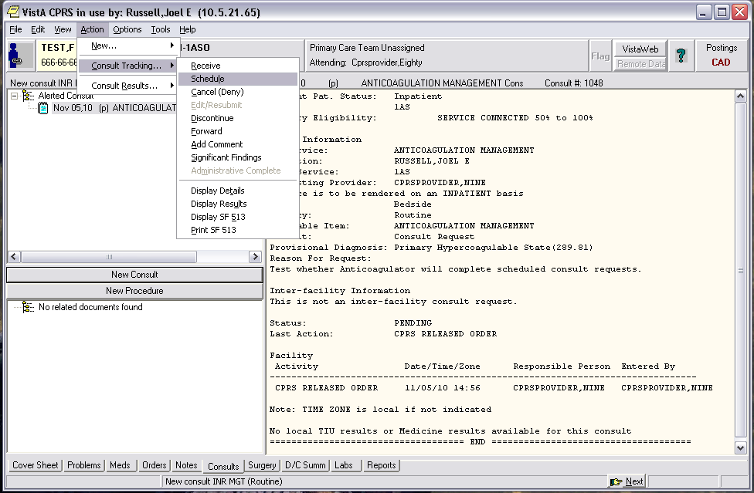

1. Enter a comment and accept the defaults in the Schedule Consult dialog that appears:

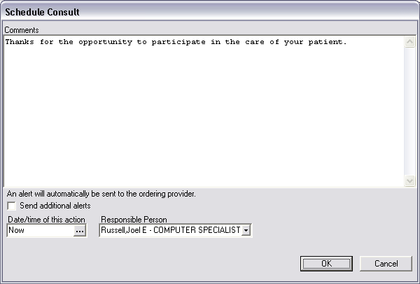

1. Click the OK button. Notice that the status of the Consult Request is updated to SCHEDULED (s).
2. Open Anticoagulator and go through the dialogs to document a complete visit (i.e., add the patient to the database, fill in all required fields, enter Pt. Notice & Comments on the Enter Information tab, etc.).
3. On the Exit tab, indicate a near-term return (e.g., five days), check the boxes to order both INR & CBC, and enter and sign the Initial Note.
4. Select Orientation Class for the visit type in the PCE Data, and click the Complete Visit button:

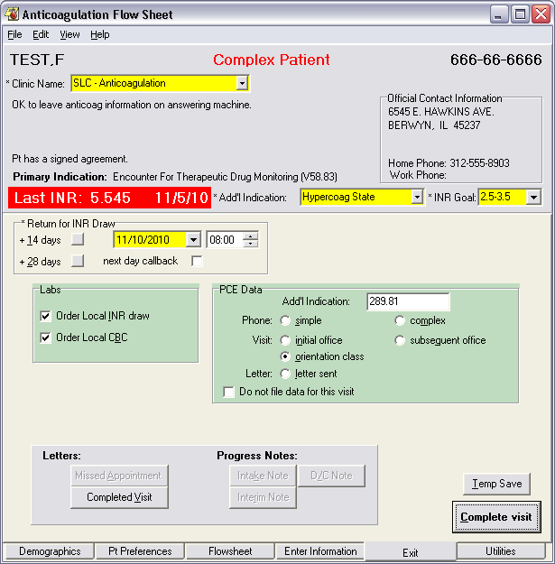

1. Check Yes or No for each of the Service Connection/Exposure questions and click the OK button. Anticoagulator will close.
2. Upon returning to CPRS, select File | Refresh Patient Data, and sign the orders in the Review / Sign Changes dialog. Go to the Orders tab. Notice that the Consults order remains scheduled, and the Intake Note is not associated with it as its result.

Scenario #5:

Remedy Tickets #394637 item #1, and #396046

Problem: When the user selects “Other” and manually enters an ICD-9-CM code for the Primary (or Additional) Indication, the visit is properly credited, and the diagnostic code is properly stored. However, it is not retrieved and presented correctly when the patient returns for subsequent visits, and must currently be manually re-entered. To replicate the problem, follow these steps:

1. Log-in to CPRS, and select a patient who is enrolled in Anticoagulation.
2. Launch the Anticoagulator from the CPRS tools menu, and remain on the Demographics tab.
3. Click the  button to change the indication for care scroll down to where the choice “Other” appears in the list. You should see something like the following:

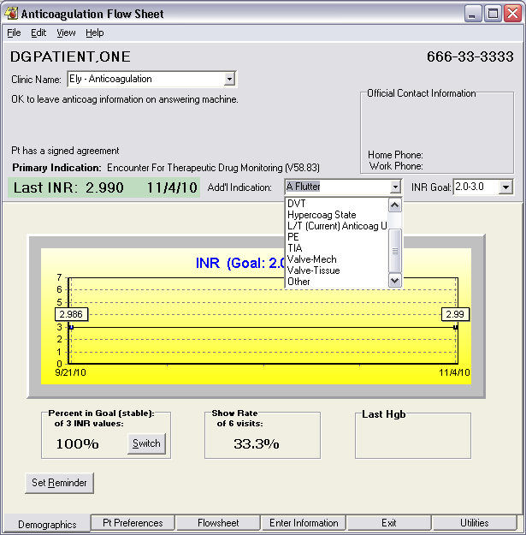

1. Select “Other” for the indication.

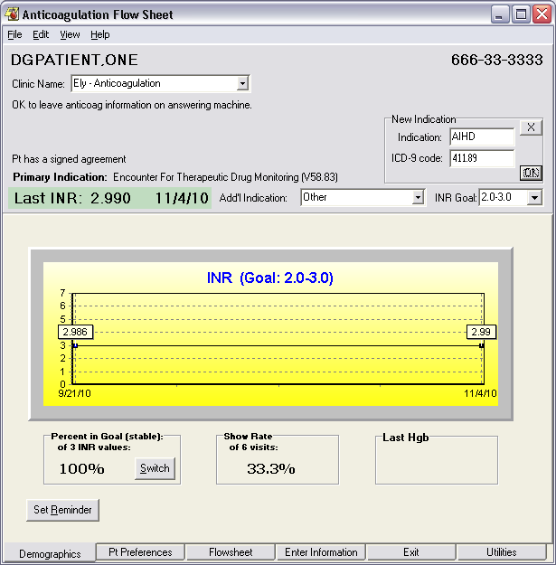

1. When the Group box labeled “New Indication” appears, type “AIHD” for the indication, and 411.89 for the ICD-9 code as shown above.
2. Click OK.
3. Navigate to the Enter Information tab. Enter the Pt. Notification and Comments.
4. Navigate to the Exit tab, and enter a future Return date for INR and be sure to select the Visit category in the PCE Data group.
5. Enter and sign an Interim Note.
6. Click Complete the Complete Visit button, answer any Service Connection questions, and exit Anticoagulator.
7. Back in CPRS, click on the Reports tab.
8. Expand the Clinical Reports branch of available reports, and choose the Anticoagulation Flowsheet. It should look something like this:

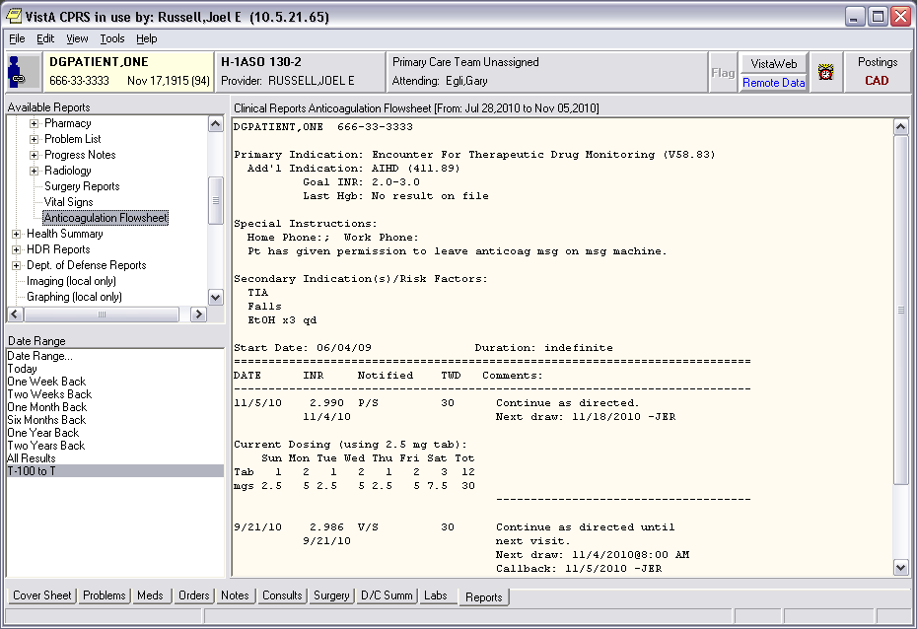

1. Note that AIHD (411.89) is properly recorded among the indications.
2. Log-in to VistA, and invoke the PCE Coordinator’s menu [PX PCE COORDINATOR MENU].
3. Choose the PCE Encounter Data Entry – Supervisor option, and select the patient for whom you just completed the encounter using Anticoagulator.
4. Choose List by Encounter to find the new Encounter that you completed.
5. Type the number of the encounter to list its details:

**PCE Update Encounter** Nov 05, 2010@12:53:28 Page: 1 of 1

DGPATIENT,ONE 666-33-3333 Clinic: ELY - ANTICOAGULATION

Encounter Date 11/5/2010 12:42 Clinic Stop: 317 ANTI-COAGULATION CLIN

1 Encounter Date and Time: NOV 05, 2010@12:42:21

2 Provider: RUSSELL,JOEL E PRIMARY Physician/Physician/Osteopath/Critical

3 ICD9 Code or Diagnosis: V58.83 ENCTR THERAP DRUG MONITOR

Provider Narrative: Encounter For Therapeutic Drug Monitoring (V58.83)

Primary/Secondary Diagnosis for the Encounter: PRIMARY

4 ICD9 Code or Diagnosis: 411.89 AC ISCHEMIC HRT DIS NEC

Provider Narrative: AIHD

5 CPT Code: 99364 ANTICOAG MGMT, SUBSEQ

Primary Diagnosis: V58.83 ENCTR THERAP DRUG MONITOR

+ Next Screen - Prev Screen ?? More Actions

ED Edit an Item TR Treatment DD Display Detail

DE Delete an Item IM Immunization DB Display Brief

EN Encounter PE Patient Ed IN Check Out Interview

PR Provider ST Skin Test QU Quit

DX Diagnosis (ICD 9) XA Exam

CP CPT (Procedure) HF Health Factors

Select Action: Quit//

1. Note that the ICD-9-CM code 411.89 and Provider Narrative AIHD appear among the diagnoses for the encounter.
2. Launch Anticoagulator again.
3. Notice that AIHD still appears in the combo box for the indication.
4. Click on the Exit tab:
5. Notice that 411.89 does *not* appear in the edit box for the indication in the PCE Data group:

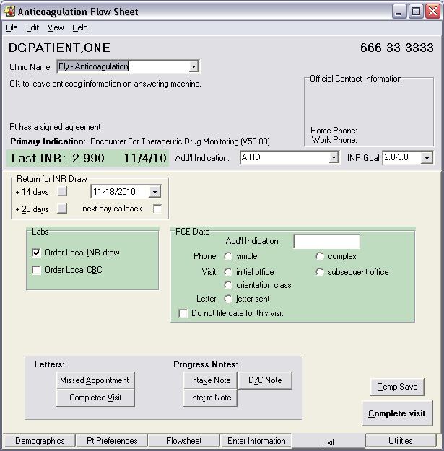

Note that the ICD-9 code 411.89 was not retrieved.

Scenario #6:

Remedy Ticket #439690

Problem: A division by zero error occurs in the Rosendaal Report, when one of the patients in the population has two consecutive INRs which are identical, one in-range and one-out, due to goal range change. To replicate the problem, follow these steps:

1. Choose any of the patients in your population (preferably one with several flow sheet entries, the most recent of which is at least a week old).
2. Open Anticoagulator from the CPRS Tools menu.
3. Specify an INR goal range of 2.5 – 3.5.
4. Using the dialog to Enter Outside Lab Data from the Enter Information Tab in Anticoagulator, enter an INR with a value of two (2.0), for a date several days prior to today:

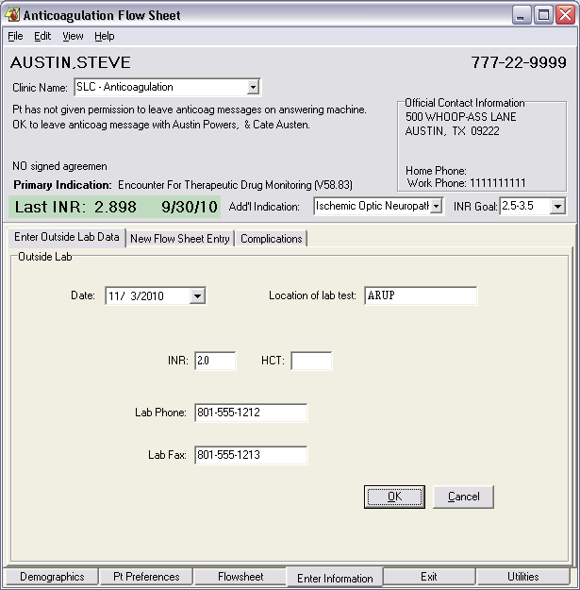

1. Enter Patient Notice and Comments on the New Flow Sheet Entry tab, and proceed to the Exit tab.
2. Choose a future date for the next draw and complete the visit, returning to CPRS.
3. Launch Anticoagulator again.
4. This time, specify an INR Goal Range of 2.0 – 3.0.
5. Repeat from step 4-6, entering 2.0 for the INR value again, with today’s date, and complete the visit, leaving the next draw date to the value you set previously.
6. Log-in to VistA and navigate to the ORAM Reports Menu and invoke the report to Calculate Time in Therapeutic Range (TTR) (Rosendaal Method):

C Anticoagulation Complication Report

R Calculate TTR (Rosendaal Method)

S Single Patient TTR

P Anticoagulation Patient Lists ...

Select Anticoagulation Management Reports Option: **R** Calculate TTR (Rosendaal Method)

Rosendaal method for percentage of INR scores in therapeutic range

Please Enter START Date: T-90//**<Enter>** (AUG 07, 2010)

Please Enter END Date: T//**<Enter>** (NOV 05, 2010)

RECORDING THAT AN ERROR OCCURRED ---

               Sorry 'bout that

          $STACK=10  $ECODE=

          $ZERROR=

1. Examine the VistA error trap. The error should look something like this:

$ZE= <DIVIDE>NGETFS+18^ORAMTTR

... I $P(NUMC,U,2)="L" S NUMPC=$$ABS^XLFMTH(LG-$P(NUMC,U)),NUMPC=NUMPC/ DIFF

Scenario #7:

Remedy Ticket #420035

Problem: An <UNDEFINED> error on start-up of the Anticoagulator client occurs when entering a new patient who’s most recent INR was cancelled. To replicate the problem, follow these steps:

1. Begin with a patient who is *NOT* enrolled in the Anticoagulation database.
2. Log-in to VistA and navigate to the Laboratory DHCP Menu [LRMENU].
3. Choose the option to Process data in Lab menu …
4. Choose the option “Fast Bypass Data Entry/Verify”
5. Follow these steps to create an order and cancel the result:

EA Enter/verify data (auto instrument)

EL Enter/verify data (Load list)

EM Enter/verify/modify data (manual)

EW Enter/verify data (Work list)

MP Misc. Processing Menu ...

Accession order then immediately enter data

Batch data entry (chem, hem, tox, etc.)

Build a load/work list

Bypass normal data entry

Download a load list to an Instrument.

Fast Bypass Data Entry/Verify

Lookup accession

Order/test status

Print a load/work list

Std/QC/Reps Manual Workload count

Unload Load/Work List

Select Process data in lab menu Option: **fast** Bypass Data Entry/Verify

Do you want to review the data before and after you edit? YES// **<Enter>**

Select Performing Laboratory: SALT LAKE CITY HCS//**<Enter>** UT VAMC 660

WANT TO ENTER COLLECTION TIMES? Y//**Y**

Select ACCESSION TEST GROUP: **HEM**ATOLOGY

Select Patient Name: **TEST,MARY J**,MARY JONES TEST,MARY JONES 4-3-55 547040355P **Pseudo SSN** YES SC VETERAN THIS IS A TEST

Enrollment Priority: Category: IN PROCESS End Date:

Select one of the following:

LC LAB COLLECT(INPATIENTS-MORN. DRAW)

SP SEND PATIENT

WC WARD COLLECT

Specimen collected how ? : SP// **<Enter>** SEND PATIENT

PATIENT LOCATION: UNKNOWN// **<Choose a valid location>**

PROVIDER: **<Choose a valid provider>**

LAB Order number: 1767

Choose one (or more, separated by commas) ('*' AFTER NUMBER TO CHANGE URGENCY)

1 CBC & MORPHOLOGY (NO DIFF) 9 PARTIAL THROMBOPLASTIN TIME

2 CBC & MORPHOLOGY (WITH DIFF) 10 FIBRIN SPLIT PRODUCTS

3 CBC 11 FIBRINOGEN

4 RETICULOCYTES & CBC 12 THROMBIN TIME

5 WINTROBE ESR & CBC 13 FLUID ANALYSIS

6 WESTERGREN ESR & CBC 14 FLUID ANALYSIS

7 COAGULATION (PT & PTT) 15 FLUID ANALYSIS

8 PROTHROMBIN TIME 16 FLUID ANALYSIS

TEST number(s): **<Enter>**

Other tests? N//**Y**

Select LABORATORY TEST NAME: **INR** PANEL

The Sample Is BLOOD LAVENDER

Same specimen/source for the rest of the order? No// **<Enter>** (No)

Select Urgency Status: ROUTINE//**<Enter>**

Select LABORATORY TEST NAME: **<Enter>**

Nature of Order/Change: WRITTEN//**<Enter>** W

You have just selected the following tests for TEST,MARY JONES 547-04-0355P

entry no. Test Sample

1 INR PANEL BLOOD

All satisfactory? Yes//**<Enter>** (Yes)

Eligibility: SC%:

Disabilities:

Enter information for INR PANEL

Select Primary ICD-9 CODE: **V58.83** ENCTR THERAP DRUG MONITOR

...OK? Yes//**<Enter>** (Yes)

Select Secondary ICD-9 CODE: **<Enter>**

LAB Order number: 1767

Collection Date@Time: NOW//**T@8** (NOV 05, 2010@08:00:00)

Print labels on: LABLABEL// **<Enter>**

Do you wish to test the label printer: NO//**<Enter>**

ACCESSION: HEm 1105 6 <1503090006>

INR PANEL BLOOD

Work Load Area: CHEM 7

TEST,MARY JONES 547-04-0355P LOC:ALBMED

Sample: BLOOD

Specimen: BLOOD

1 INR PANEL

TEST,MARY JONES SSN: 547-04-0355P LOC: ALBMED

Pat Info: Sex: FEMALE Age: 55yr as of Nov 05, 2010

Provider: CPRSPROVIDER,NINE Voice pager:

Phone: 555-1018 Digital pager: 555-1223

ACCESSION: HEm 1105 6

11/5 08:00d

PT //CANC

INTERNATIONAL NORMALIZED-RATIO //**canc**

ANTICOAGULANTS //**canc**

PTT //**canc**

Select COMMENT:

TEST,MARY JONES SSN: 547-04-0355P LOC: ALBMED

Pat Info: Sex: FEMALE Age: 55yr as of Nov 05, 2010

Provider: CPRSPROVIDER,NINE Voice pager:

Phone: 555-1018 Digital pager: 555-1223

ACCESSION: HEm 1105 6

11/5 08:00d

PT CANC

INTERNATIONAL NORMALIZED-RATIO canc

ANTICOAGULANTS

PTT canc

SELECT ('E' to Edit, 'C' for Comments, 'W' Workload): **<Enter>**

Approve for release by entering your initials: **<your initials>**

Select Patient Name: **<Enter>**

1. Log-in to CPRS, and choose the patient for whom you just cancelled the INR result.
2. Launch Anticoagulator from the Tools Menu.
3. Carefully note any errors that are reported.
4. Examine the VistA error trap. You should see something like this:

$ZE= <UNDEFINED>COMPTEST+6^ORAM1 *X

 S ORAMTEMP=$P(ORAMZERO,"^",1) D DT^DILF(,ORAMTEMP,.X) S $P(ORAMZERO,"^",1)= X

Scenario #8:

Remedy Ticket #439768

Problem: Lab orders will not be placed when a visit is completed using Anticoagulator unless a letter is generated or note was also written. To replicate the problem, follow these steps:

1. Log-in to CPRS as a Clinician (i.e., holder of ORES and PROVIDER keys), and select a patient who is enrolled in Anticoagulation.
2. Launch the Anticoagulator from the CPRS tools menu, and click on the Enter Information tab.
3. Enter the patient notice and comments and click OK:

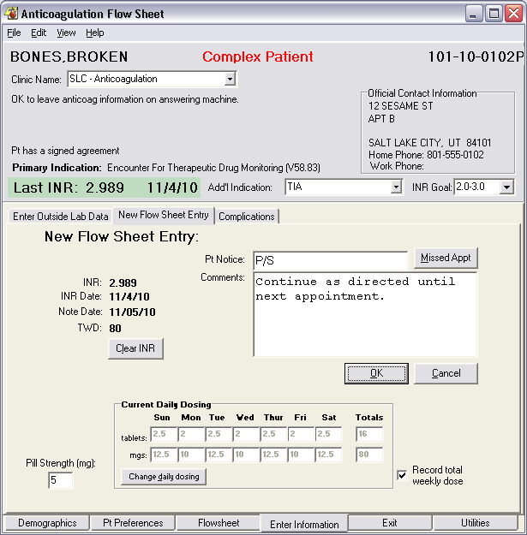

1. Proceed to the Exit tab, and enter a future Return date. Be sure that the checkbox to order an INR is checked and the radio button indicating a simple phone visit is selected. ***Do NOT create a letter or enter any of the Progress Notes.*** Click the complete visit button.

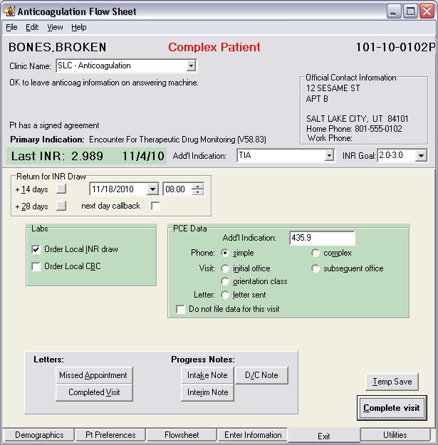

1. Check Yes or No for each of the Service Connection/Exposure questions and click OK. The Anticoagulator will close.
2. Return to CPRS and choose Refresh Patient Data from the File menu. Notice that the Review/Sign Changes dialog fails to appear, and that a new INR order fails to appear among the Active orders on the Orders tab.

Scenario #9:

Remedy Ticket #439776

Problem: Changes in patient location during a session of the Anticoagulator client are not recorded when the user clicks the Save and Exit button, rather than filing a complete visit. To replicate the problem, follow these steps:

1. Log-in to CPRS, and select a patient who is enrolled in Anticoagulation.
2. Launch the Anticoagulator from the CPRS tools menu, and click on the Pt. Preferences tab:

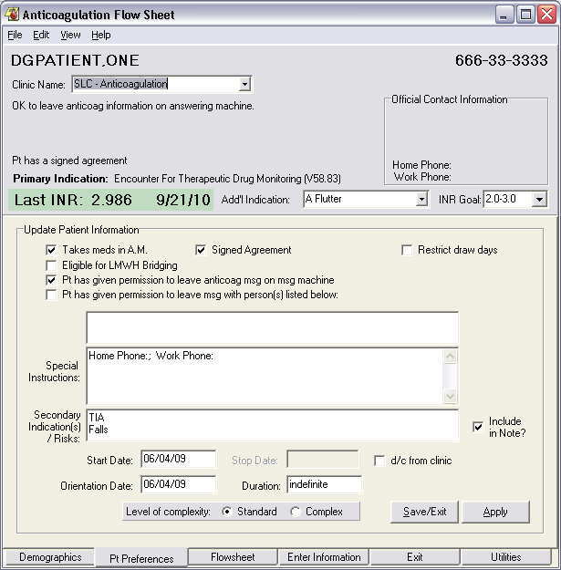

1. Using the Clinic Name combo box, select a different clinic:

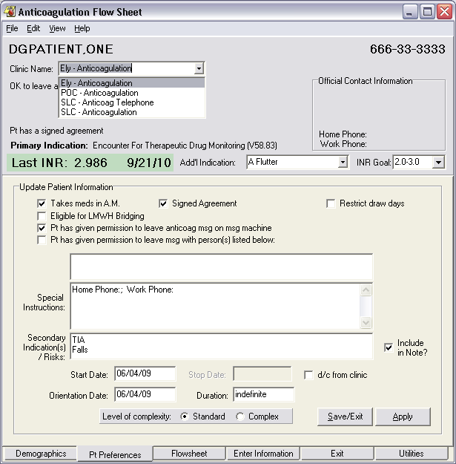

Then click Save/Exit.

Choose a different location.

1. Click the Save/Exit Button. The following dialog will appear:

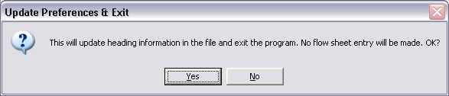

1. Click Yes. Anticoagulator will close, and return focus to your CPRS session.
2. From the Tools menu, restart Anticoagulator:

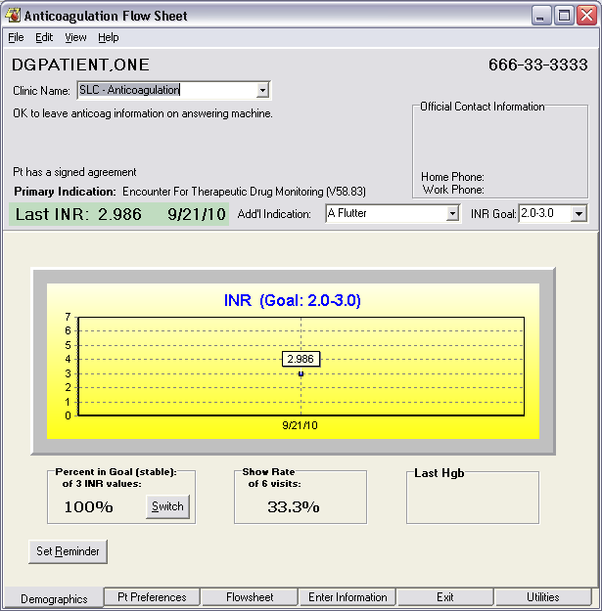

Note change in location was *not* saved.

1. Notice that the Clinic Name has reverted to the value it had prior to your change.

Scenario #10:

Remedy Ticket #439782

Problem: INRs may not be ordered for collection on weekends. Although this was acceptable at all of the original test sites for Anticoagulator, Denver reported that they often need to order for weekend collection. To replicate the problem, follow these steps:

1. Log-in to CPRS, and select a patient who is enrolled in Anticoagulation.
2. Launch the Anticoagulator from the CPRS tools menu, and click on the Exit tab.
3. In the Return for INR Draw Date chooser, click on the button to open the calendar control:

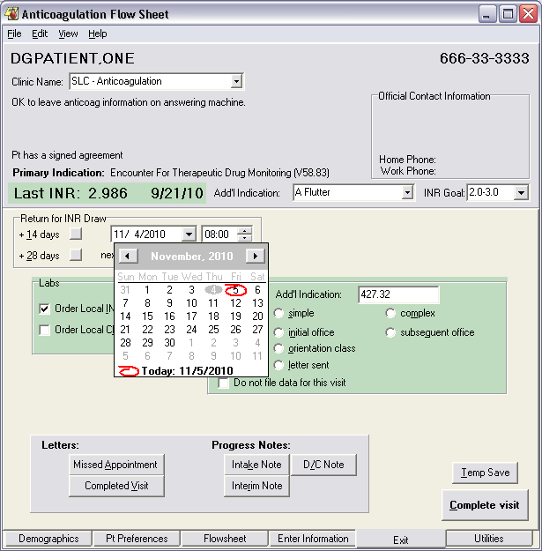

1. Click on the Saturday nearest to today’s date. The calendar will close, leaving the date temporarily set to that date:

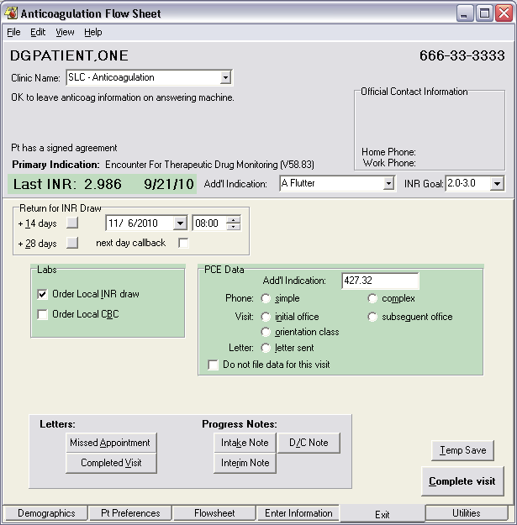

1. Next, press the tab key to leave the Date Chooser:

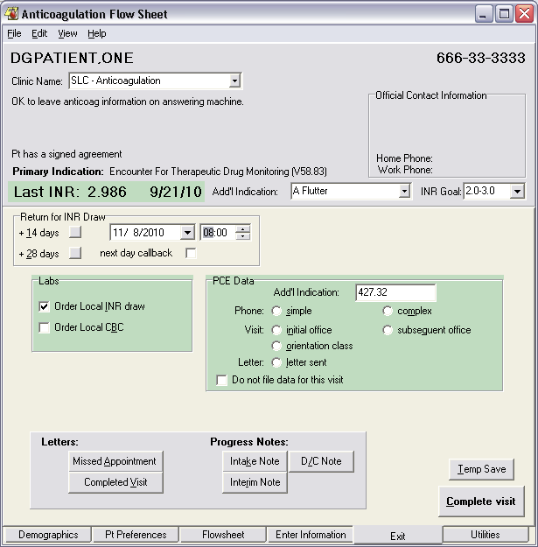

Note that Return date was incremented to Monday.

1. Notice that the date automatically incremented to the Monday following the Saturday date that you had selected.
2. Finally, repeat the date selection, but attempt to choose the nearest Sunday after the present date. Observe what happens when you tab away from the Date Chooser.

Congratulations! You’ve finished your first pass of the Test Plan. Now, install patch OR*3*339, and execute each of the scenarios again. Please carefully note your results, and report your findings.